Notes: Create a Jira ticket for this assignment, work on the tasks listed below, and submit the task completion document by EOD with clear steps and required evidence (outputs/screenshots)

Task 1: Create user with name Techie and provide sudo access to user.
Steps:
- Created Techie user using “useradd Techie” command
- Added password to this user using “passwd Techie” command
- Went to the sudoers file in etc/sudoers to add Techie in the sudoers list
Evidence: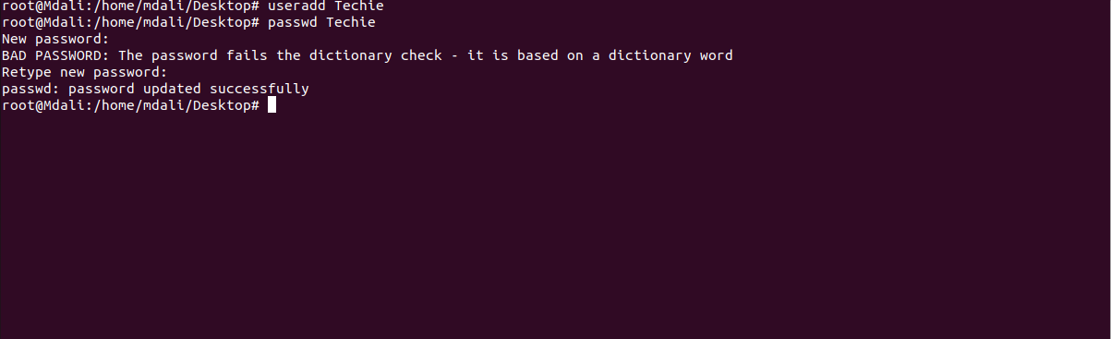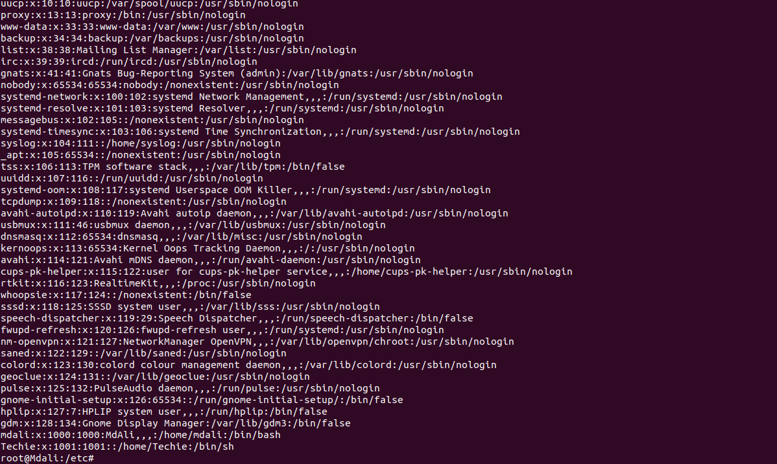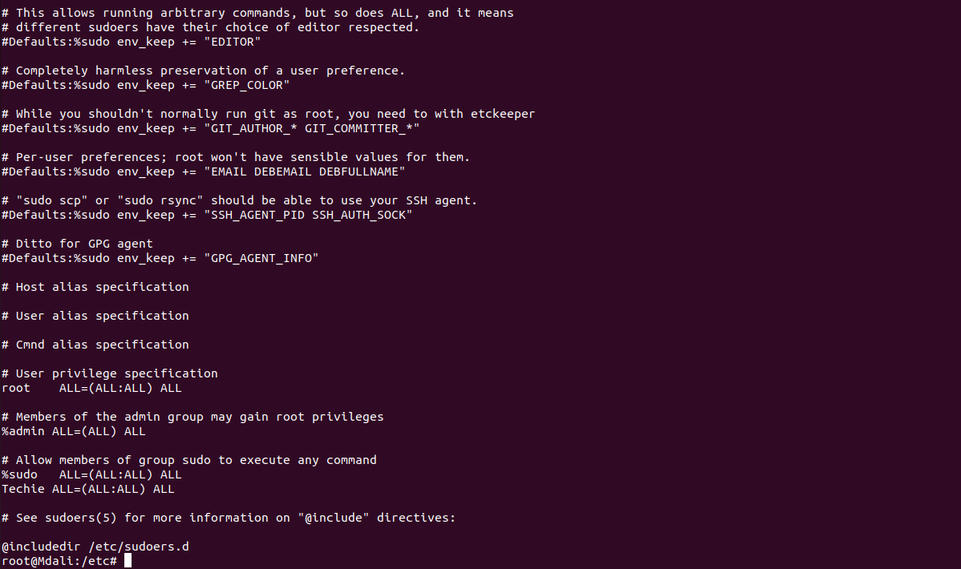
Task 2: Navigate to the home directory
Steps:
- Used “cd ~” to navigate to home directory
- Used “pwd” to reconfirm
Evidence:
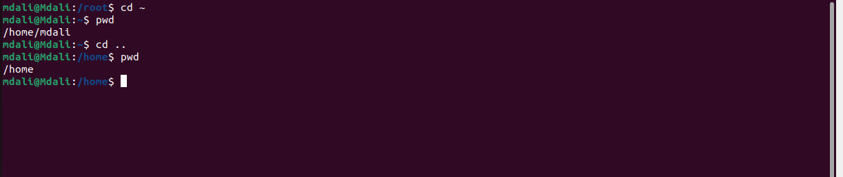
Task 3: Create a new directory.
Steps:
- Created a new directory using “mkdir” command
- Used “ls” command to confirm whether it is created or not
Evidence:


Task 4: List the contents of a directory.
Steps:
- Went to the home directory using “cd ~” command
- Usind “ll” command to see the contents of home directory

Evidence:
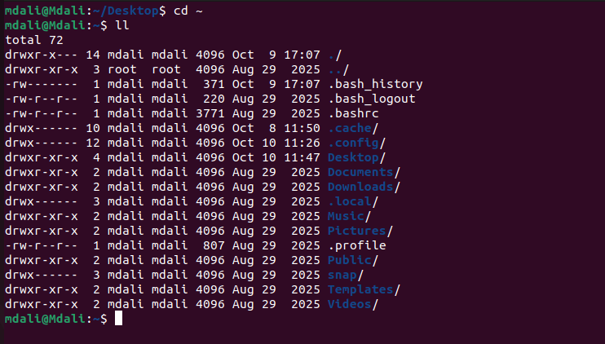
Task 5: Change the current directory.
Steps:
- Used “cd” command to change the current directory
- Used “pwd” to check the current and previous path
Evidence:
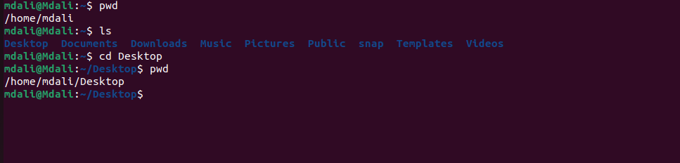
Task 6: Create a new empty file.
Steps:
- Used “touch” command to create an empty (0 bytes) file
- Used “ls” to confirm whether it is created or not
Evidence:

Task 7: View the contents of a file.
Steps:
- Used “cat /etc/sudoers” to see the contents of file named sudoers
Evidence:
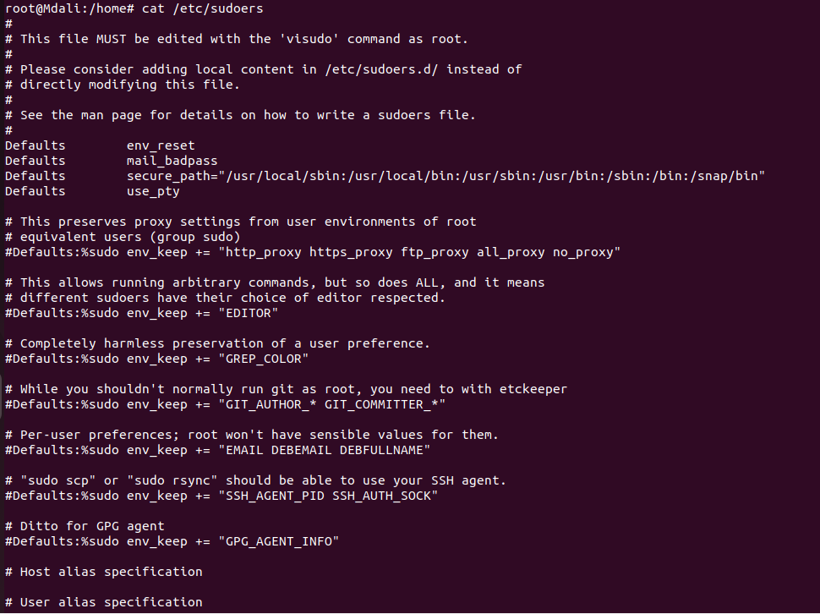

Task 8: Copy a file to another location.
Steps:
- Used “pwd” to know the location path where file needs to be copied
- Went back to the directory where the file is located and used “cp newfile /home/mdali/Desktop/New_Directory” to copy paste the file
- Made sure it is copied and pasted using “ls” command in both directories (source and copied)
Evidence:
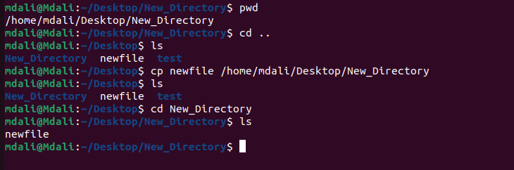
Task 9: Move a file to another location.
Steps:
- Went to the directory where the file needs to be moved and used “pwd” to know the location path
- Went back to the source directory to move the file using “mv newfile /home/mdali/Desktop/New_Directory”
- Made sure it is moved using “ls” command in both directories (source and moved)
Evidence:
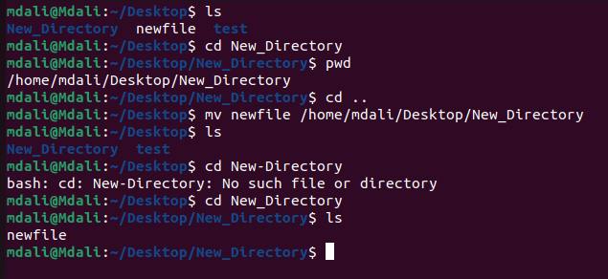
Task 10: Rename a file.
Steps:
- Used “mv” command to remane a file
- Used “ls” command to made sure it is renamed
Evidence:
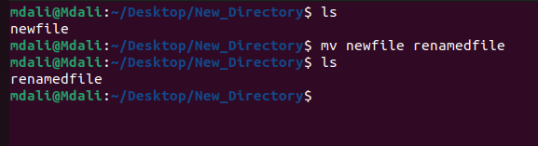
Task 11: Delete a file.
Steps:
- Deleted the file using “rm renamedfile” command
- Made sure it is deleted using “ls” command
Evidence:
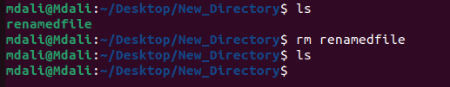

Task 12: Grant or revoke permissions on a file or directory.
Steps:
- Checked the current permissions of the file new “ll” command
- Changed the permissions using “chmod 777 renamedfile” command
- Made sure it is changed by using “ll” command
Evidence:
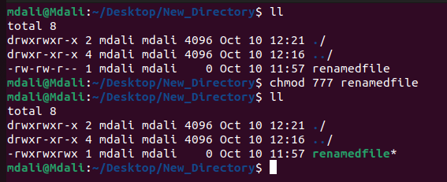
Task 13: View the current date and time.
Steps:
- Used “date” command to check the current date and time
Evidence:

Task 14: Check the system uptime
Steps:
- Used “uptime” to check the uptime of the system
Evidence:
Task 15: View the running processes.
Steps:
- Used “ps” command to see running processes
- Used “ps -ef” command to see the details of running processes
Evidence:
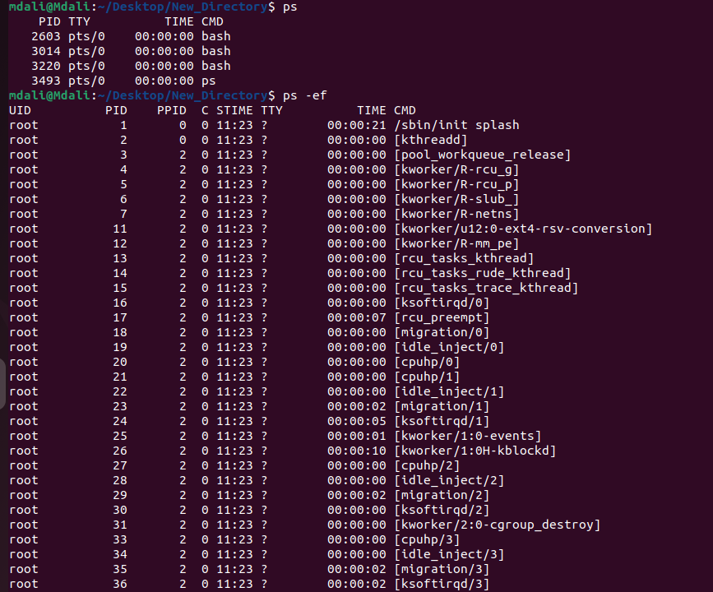
Task 16: Kill a running process.
Steps:
- Created a new process by using “sleep 300 &” command
- Used “ps” to check if the process if running
- Checked PID of the running task and used “kill 9280” command to kill the process
- Made sure it is killed using “ps” command
Evidence:
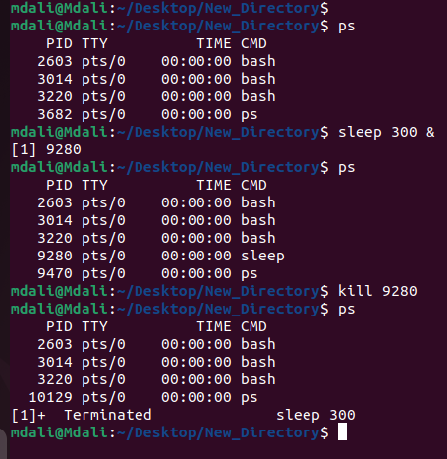
Task 17: Install a package using the package manager (e.g., apt or yum).
Steps:
- Used “apt install tree” command to install a package named “tree”
- Made sure it is installed successfully by using “tree --version” command
Evidence:
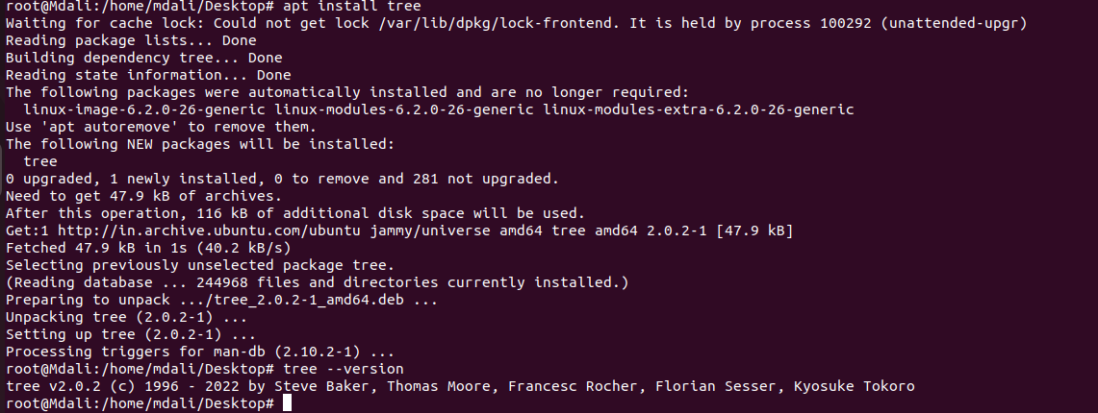
Task 18: Update the system packages.
Steps:
- Checked if updates are available using “apt update” command
- Checked what is upgradable using “apt list --upgradable”
- Updated system packages using “apt upgrade” command
Evidence:
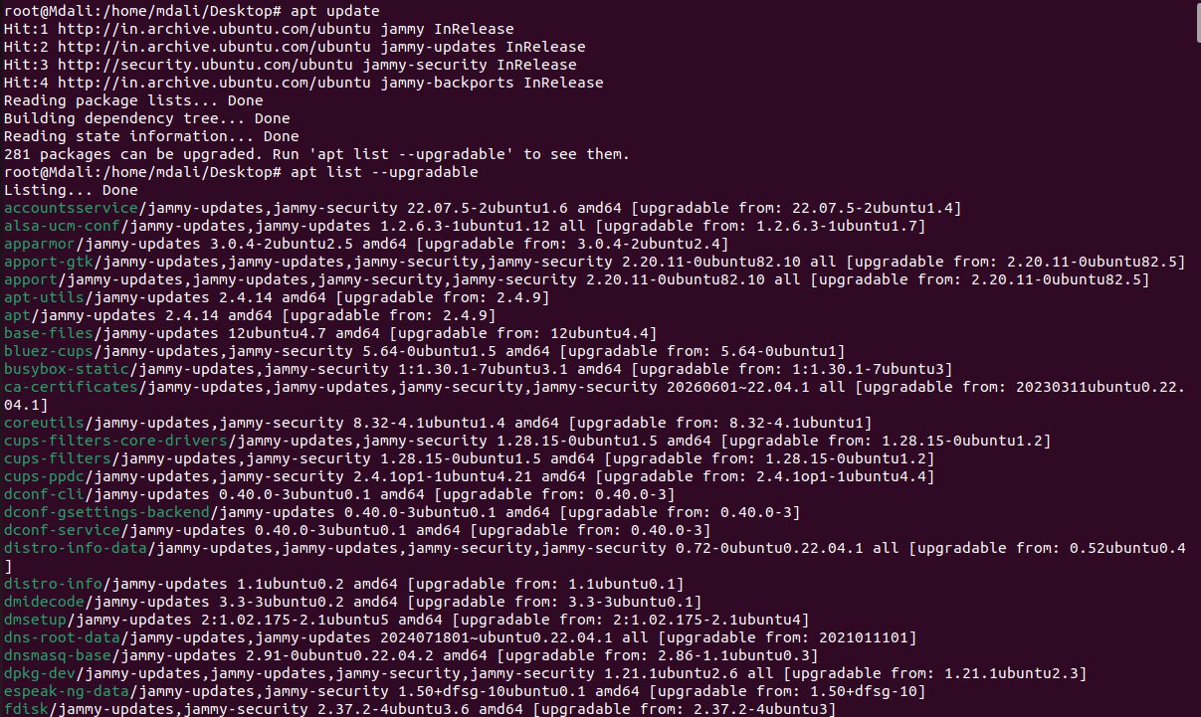
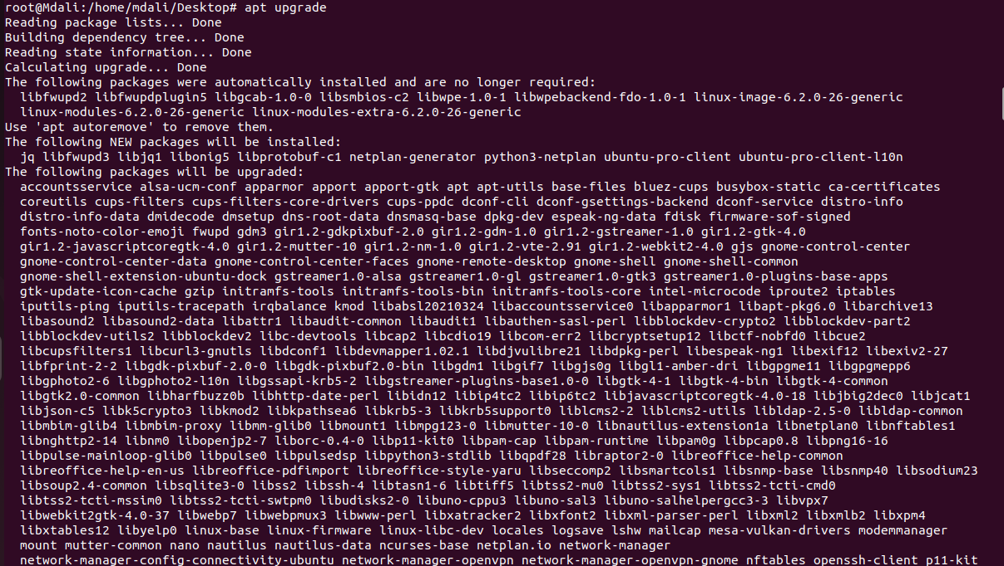
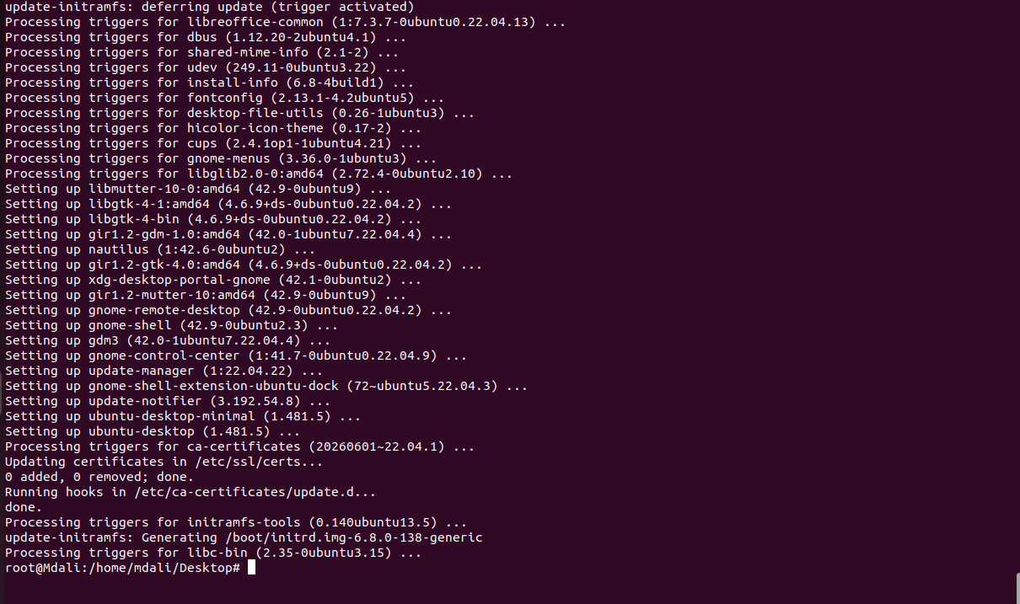
Task 19: Create a symbolic link.
Steps:
- Created file using single redirection and saved file by name test, “echo “Hello kitty” > test”
- Created symbolic link using “ln -s test link” command
- Checked if the link is created using “ll” command
- Checked if the link is working using “cat link” command
Evidence:
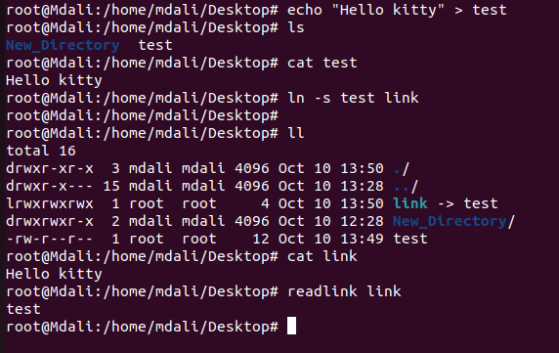
Task 20: Search for files using the find command.
Steps:
- Searched for a file named “test” using “find / -name test” command
Evidence:
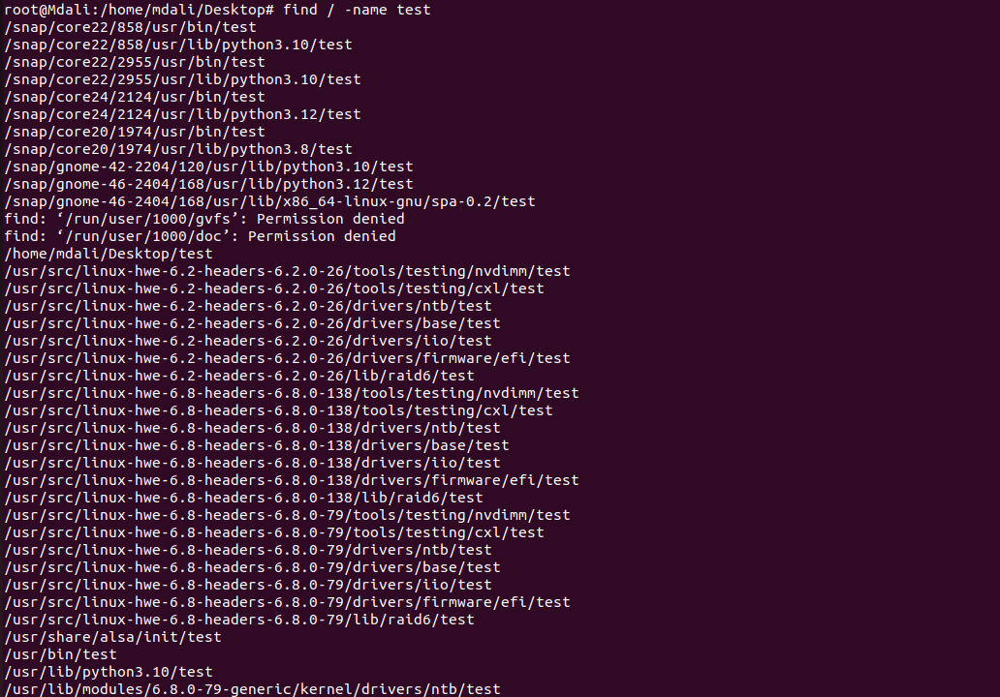
Task 21: Compress and decompress files using tar.
Steps:
- Compressed the file named “test” by using “tar -czvf backup.tar.gz test” command
- Checked if it is compressed by using “ls -lh backup.tar.gz” command
- Decompressed the file in a newly made directory (extracted) using “tar -xzvf backup.tar.gz -C extracted” command
- Checked if it is decompressed using “cat /home/mdali/Desktop/extracted/test” command
Evidence:
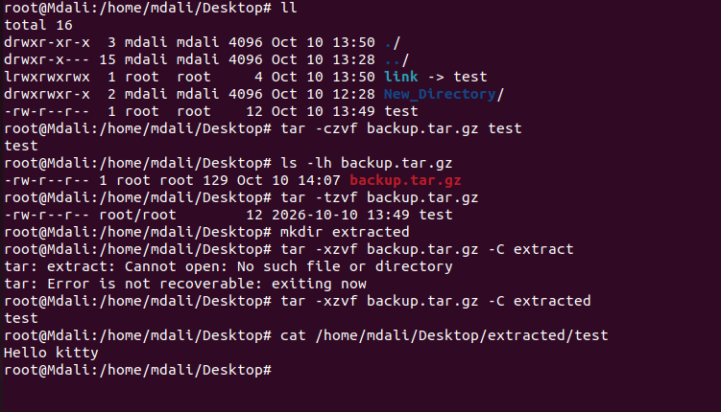
Task 22: Monitor system resources with top or htop.
Steps:

Evidence:
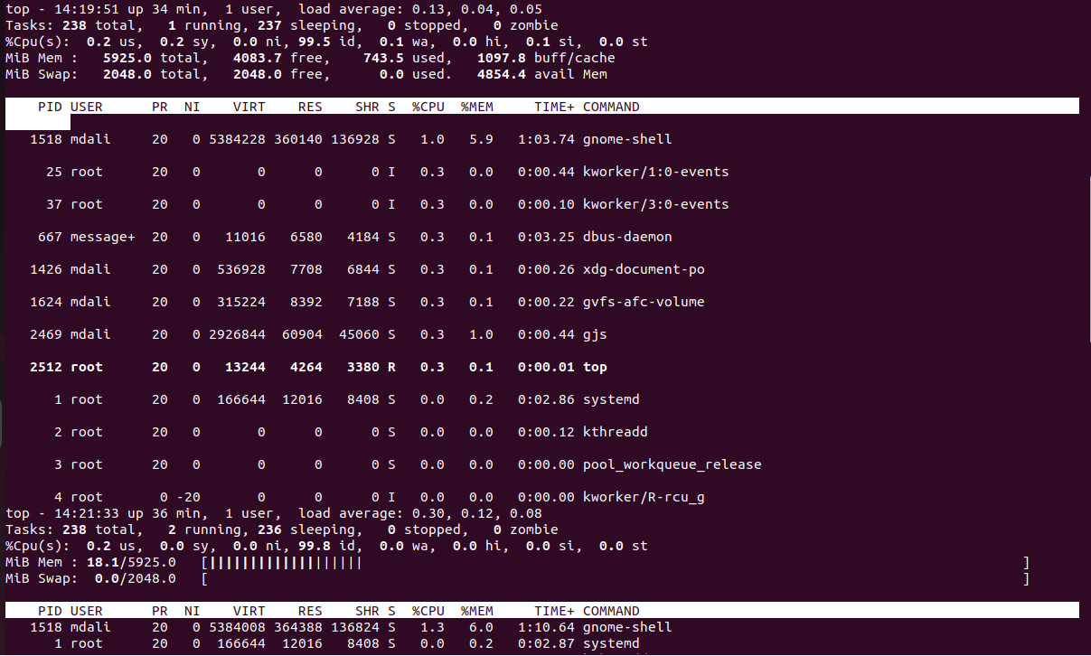
Task 23: Create and manage user groups.
Steps:
- Checked if the appteam group is already existing using “getent group appteam” command
- Created a new group using “groupadd appteam” command
- Added user “mdali” to this new group without removing them from their original group using “usermod -aG appteam mdali” command
- Checked if the user is added or not using “getent group appteam” command
- Created a new directory in this group and gave permissions to the group using “chown, chmod” commands
Evidence:
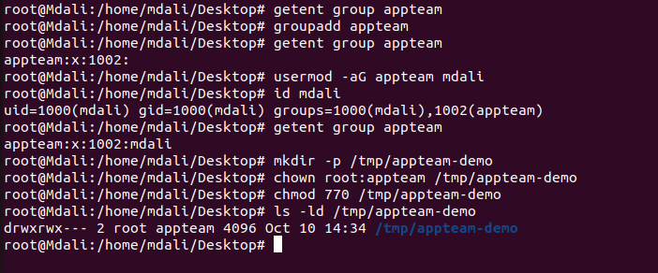
Task 24: Set up SSH password less authentication.
Steps:

Evidence:
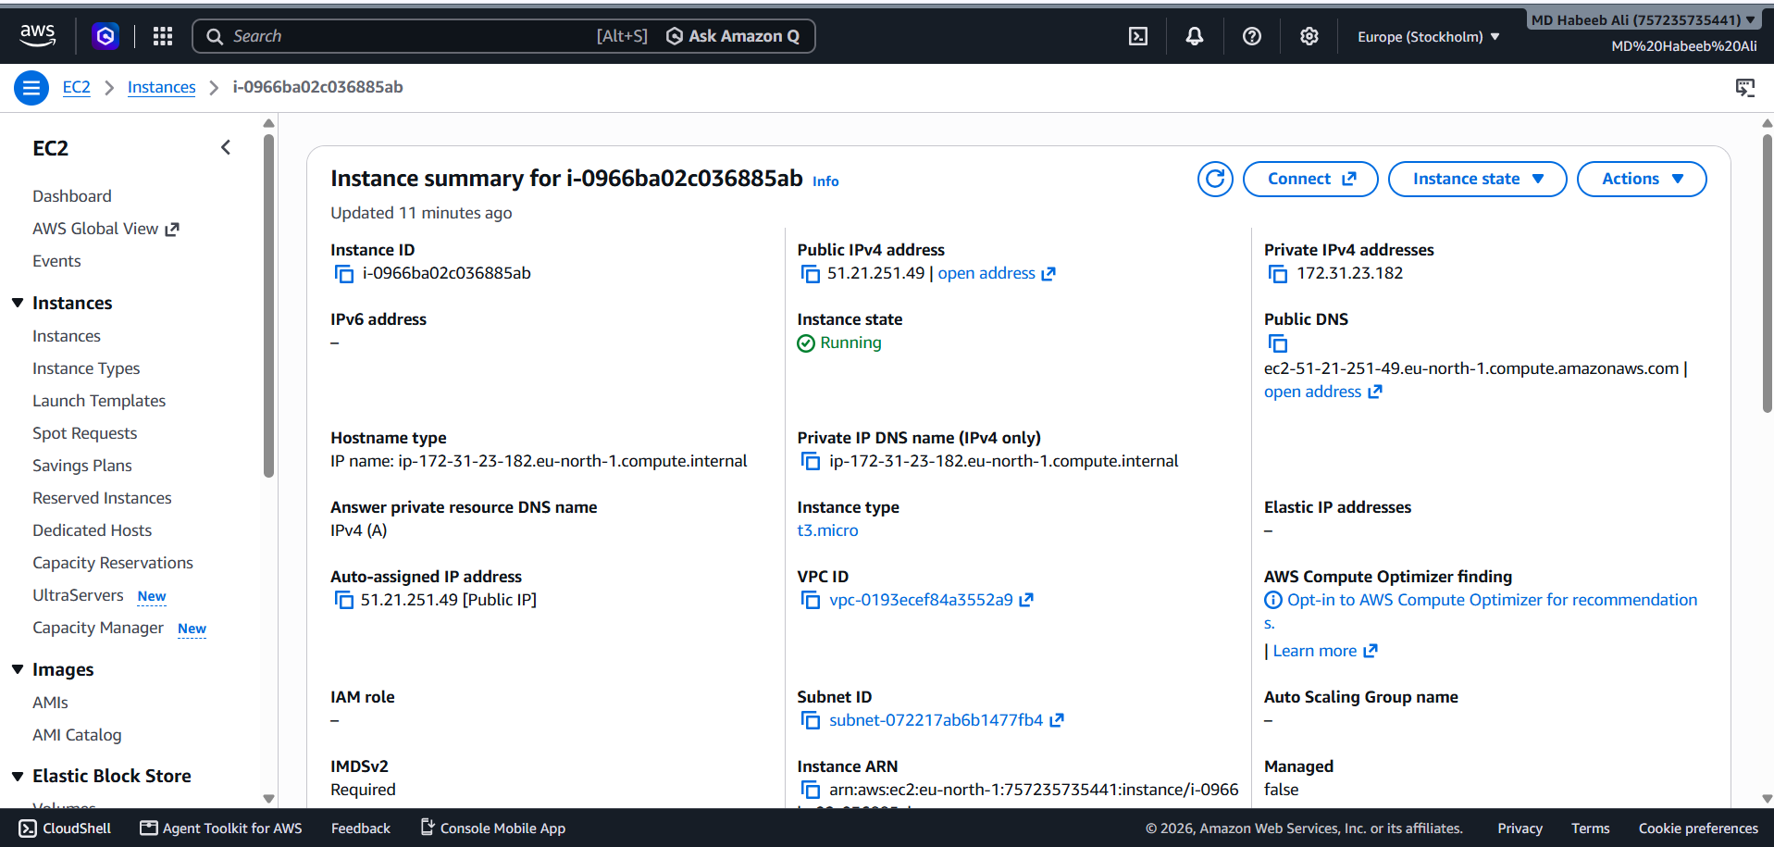
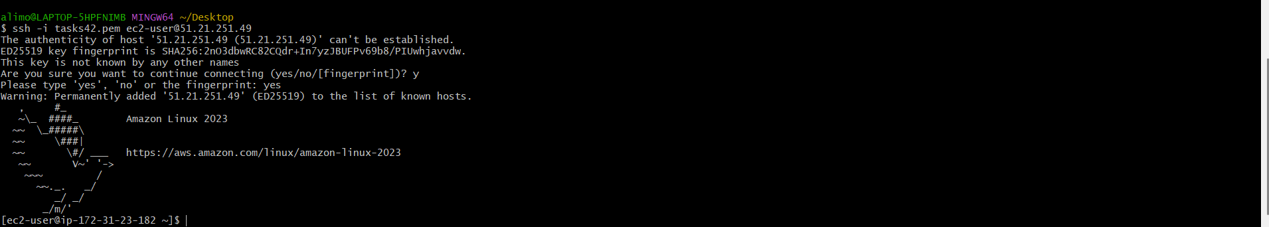
SSH passwordless authentication in Ubuntu
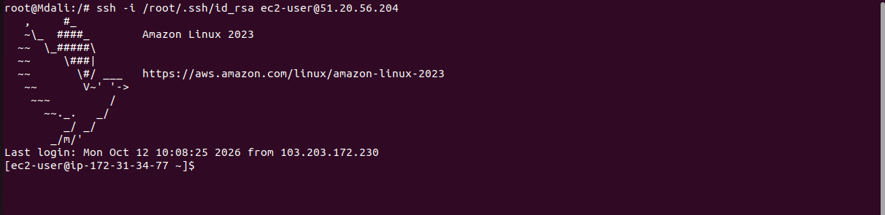

Tast 25: Monitor log files using tail or grep.
Evidence:
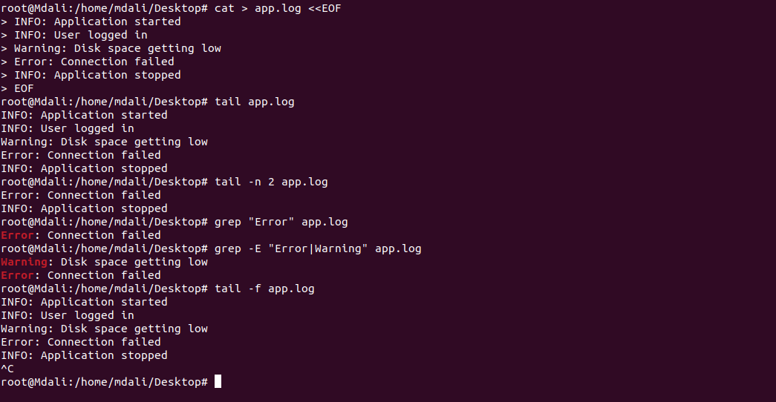
Task 26: Set up a web server (e.g., Apache or Nginx).
Evidence:
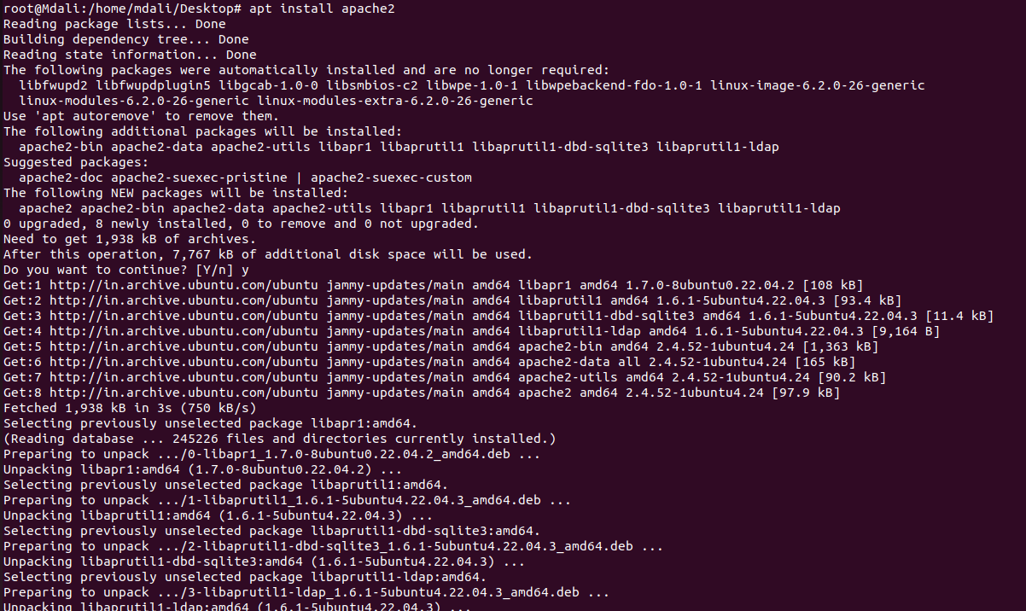
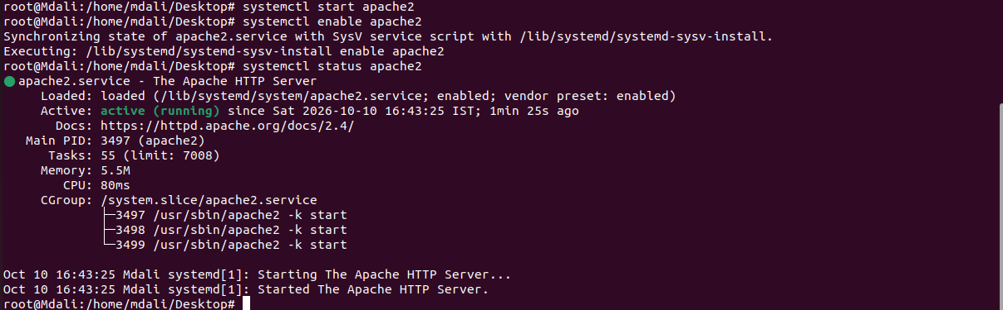
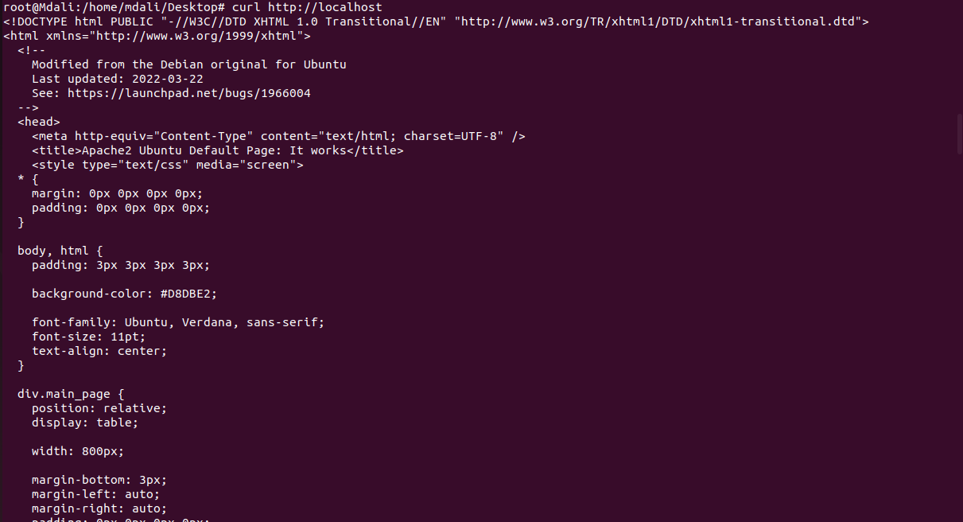
Task 27: Configure and secure a MySQL Database.
Evidence:
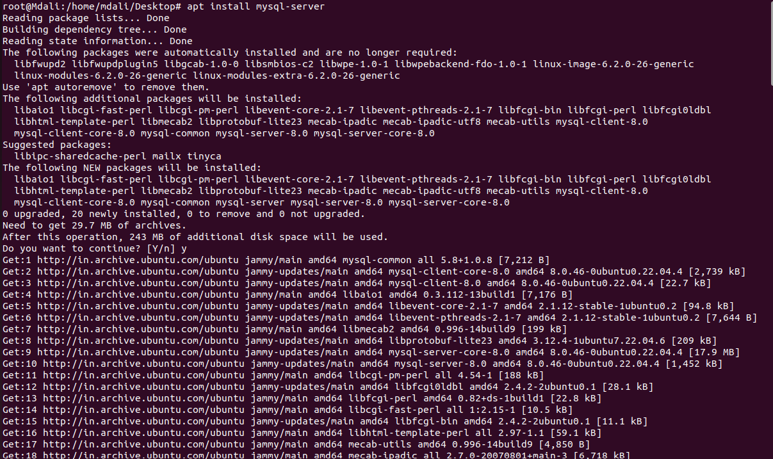
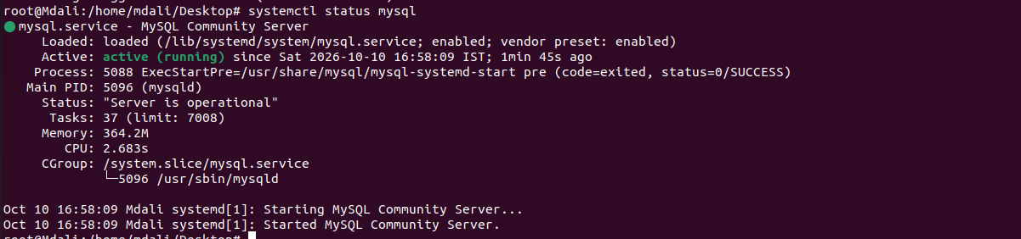
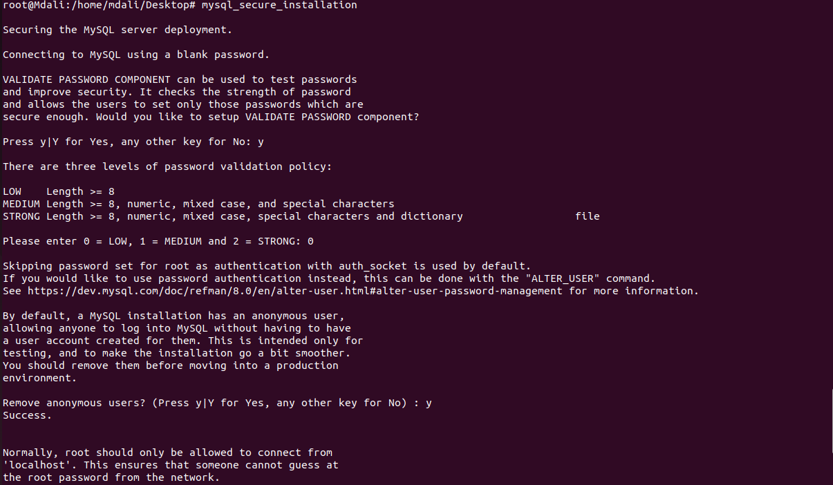
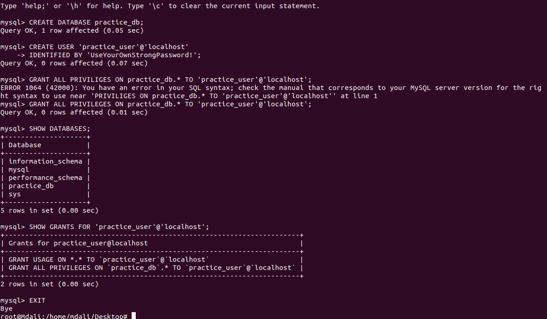
Task 28: Set up a Application Server (e.g.,Apache Tomcat)
Evidence:
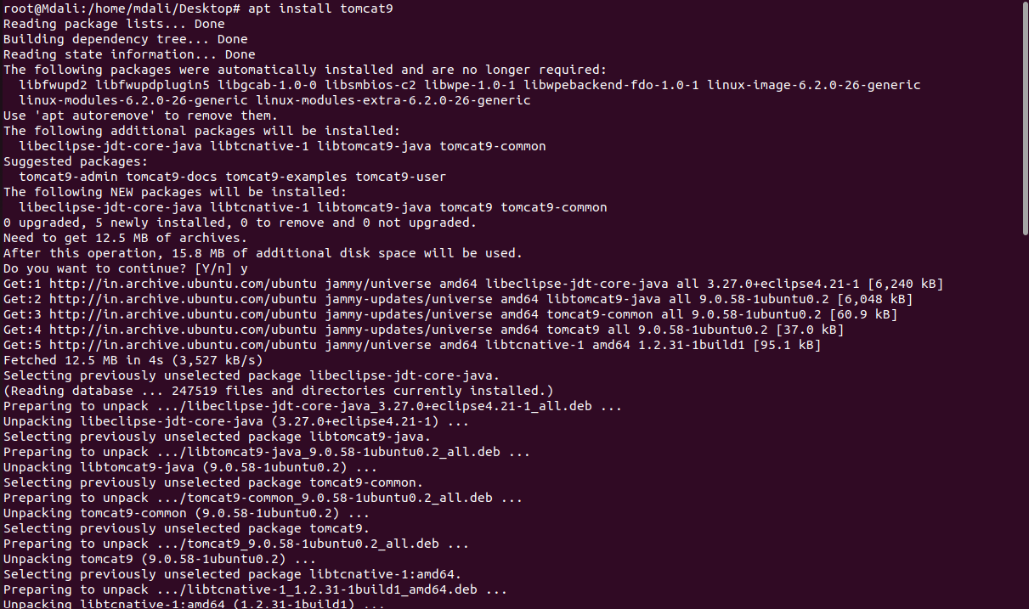
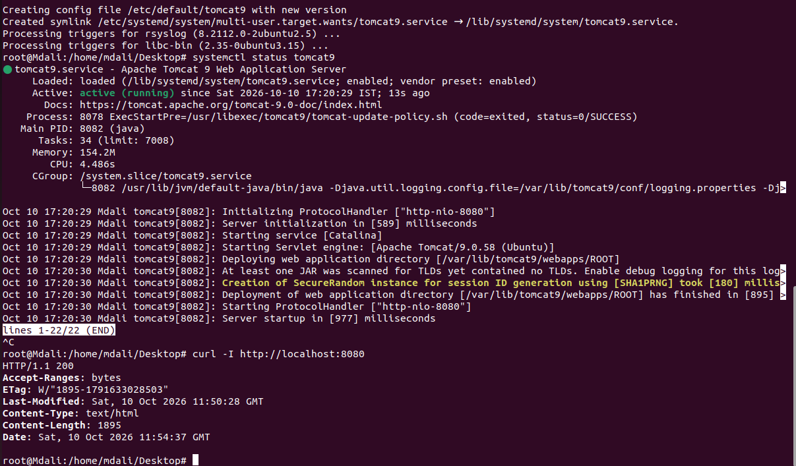
Task 29: create a service file for Apache Tomcat.(Should execute by using systemtctl command)
Evidence:
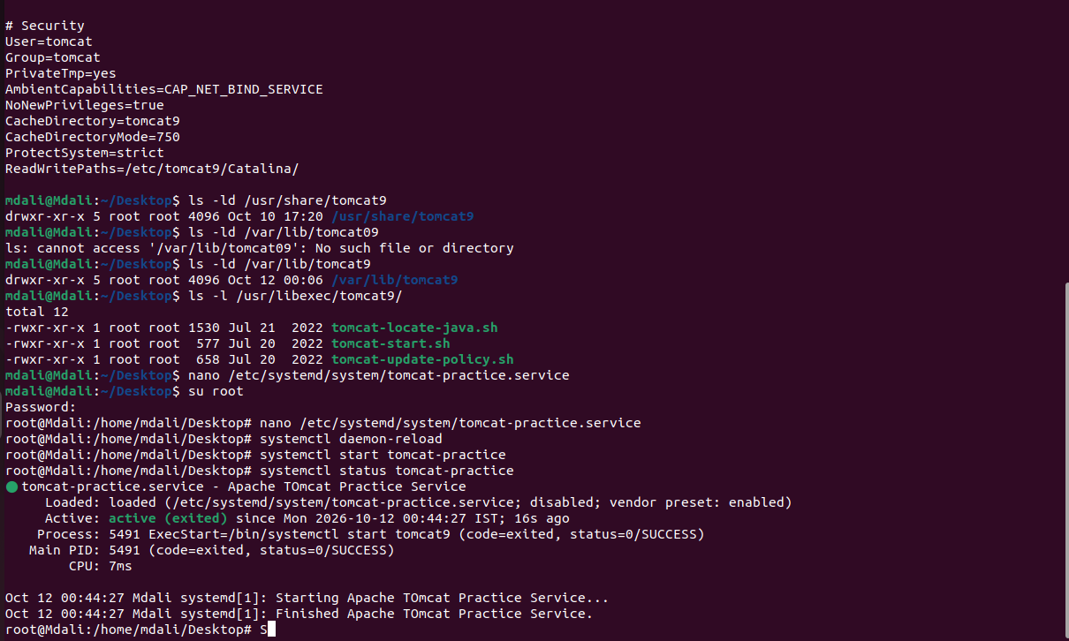
Task 30: Print specific columns from a delimited file.
Evidence:
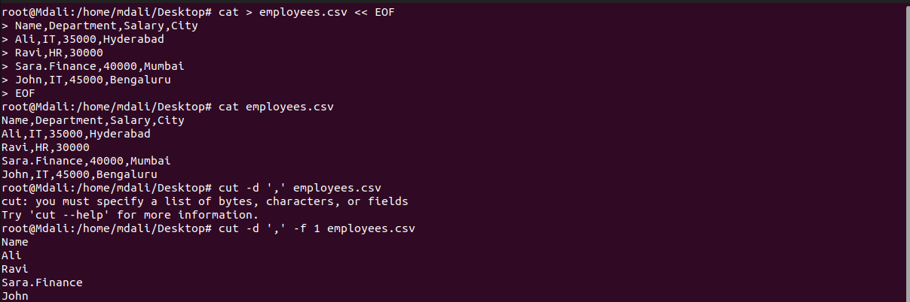
Task 31: Filter and print lines based on a specific pattern or condition.
Evidence:

Task 32: Calculate and print the average, sum, or other statistics of a column.
Evidence:
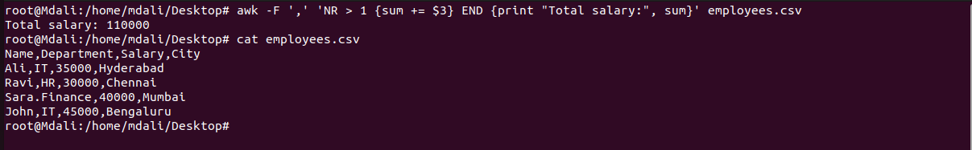
Task 33: Perform string manipulation, such as extracting substrings or changing case.
Evidence:
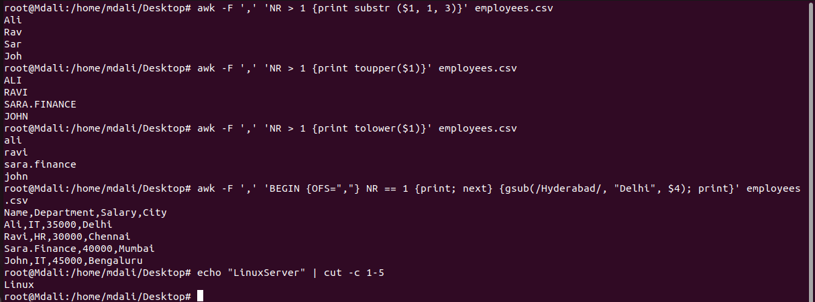
Task 34: Count the occurrences of a specific pattern in a file.
Evidence:
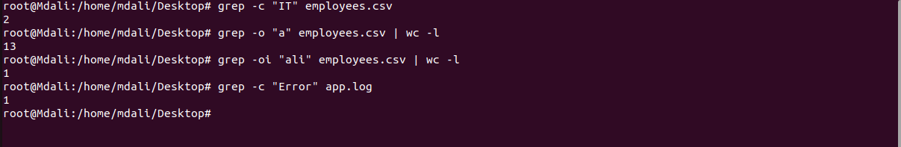
Task 35: Sort lines based on a specific field or column.
Evidence:
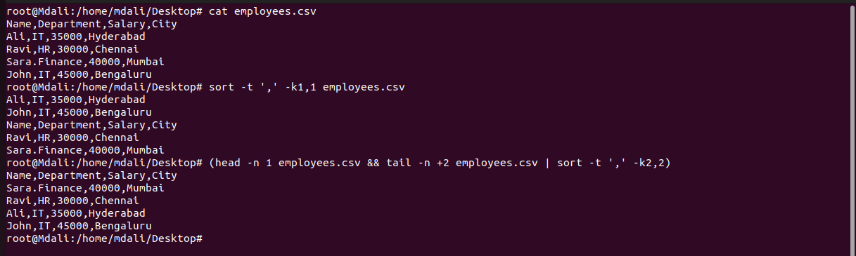
Task 36: Merge multiple files based on a common field or column.
Evidence:
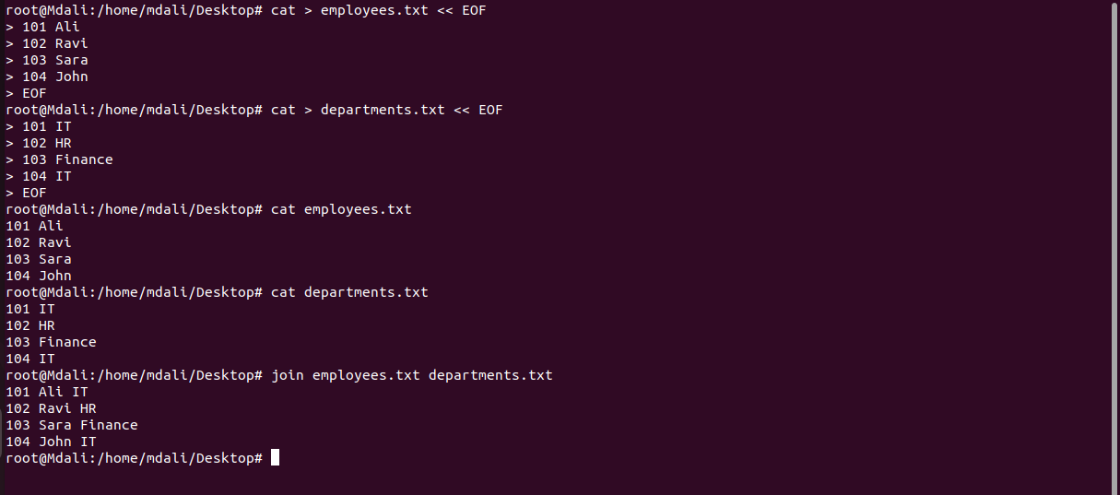
Task 37: Substitute text in a file using search and replace.
Evidence:
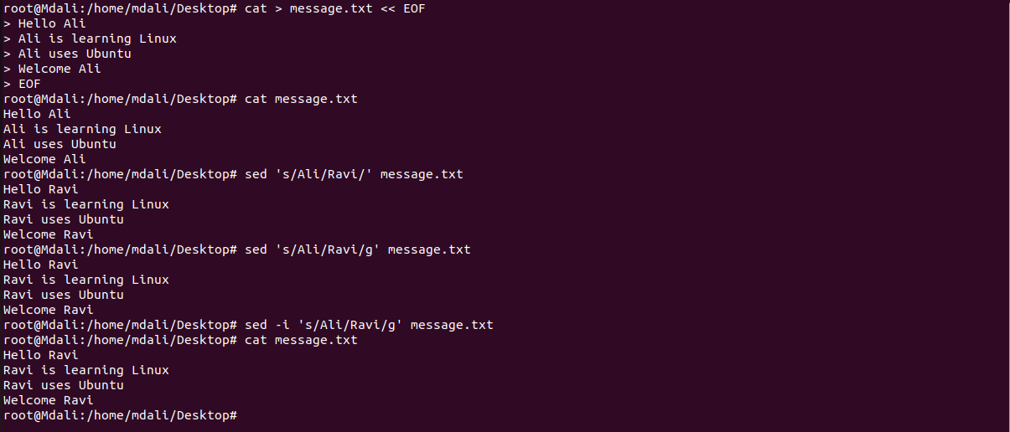
Task 38: Delete specific lines based on a pattern or line number.
Evidence:
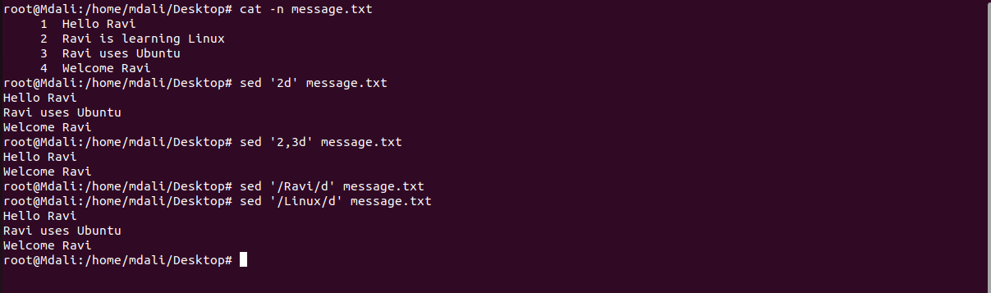
Task 39: Append or insert text before or after a specific pattern or line.
Evidence:
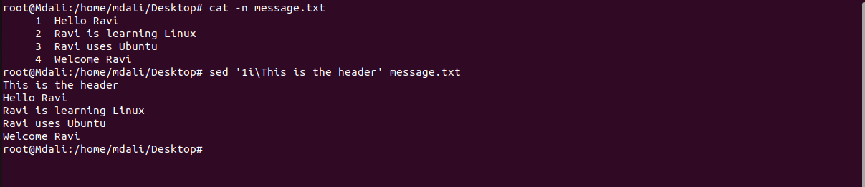
Task 40: Print only specific lines from a file.
Evidence:
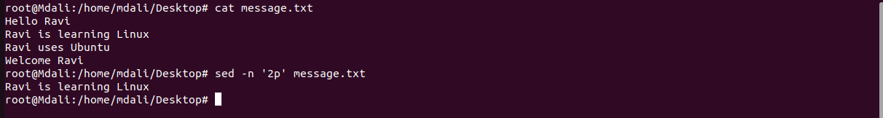
Task 41: Copy file from linux to windows machine
Evidence:
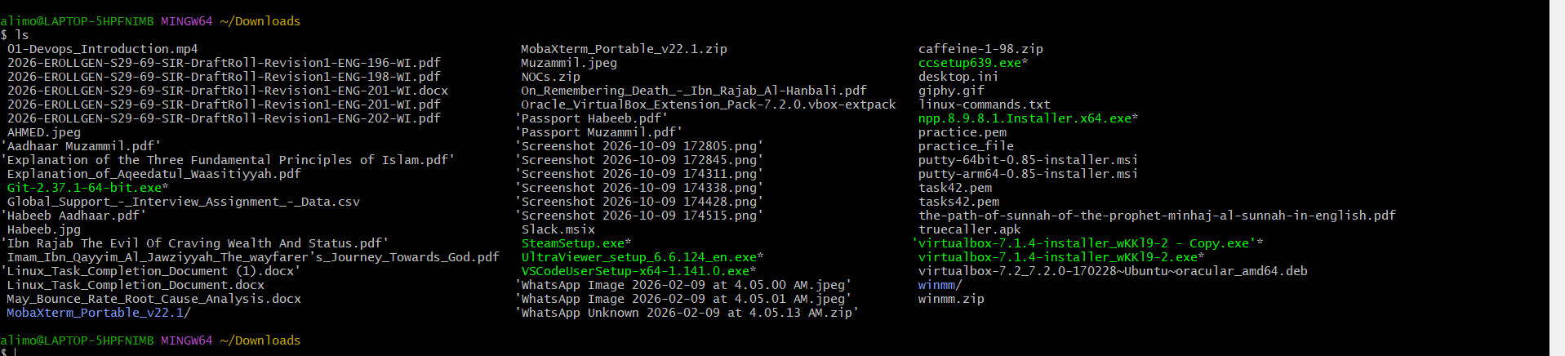
Task 42: 5 use cases for AWK and 5 use cases for sed
Evidence:
